Buxworth Cricket Club – ECB COVID Guidelines
Guide for Visiting Teams - Revision 2 (Mar 2021)
- Introduction and Scope

  - The following instructions are intended for circulation to all visiting teams wishing to play at Buxworth Cricket Club.
  - The assumption is made that participants in all visiting teams will have been familiarised with the requirements of the ECB guidelines by their own club. Therefore this guide is designed only to define the local facility arrangements in place at Buxworth Cricket Club.
  - The full club policy document regarding play under the current ECB guidelines is published on the club website at www.buxworthcricketclub.org .

- Social Distancing Arrangements

  - 2m social distancing rules should be maintained at all times at the cricket ground, with the exception of certain defined circumstances during gameplay. Please take extra care near potential pinchpoints such as ground entrances and while waiting for toilet facilities. Spectators should not congregate in groups larger than 6 individuals.
  - Segregated areas will be marked on the ground boundary for players and visitors to congregate whilst not on the field of play. Social distancing measures remain in force in these areas.

- Club Facilities

  - Due to the extra burden placed on car parking under the Step 4 guidelines, where possible the football pitch adjacent to the cricket ground will be utilised on matchdays. This provides ample parking provision allowing social distancing to be easily maintained. In addition, there are 3-4 entry points into the ground from this area, reducing potential pinchpoints.
  - In the event that the match is scheduled on a day when the football pitch is not available, this will be communicated in advance. Alternative parking is extremely limited and may be some distance from the ground. Please avoid parking adjacent to the ground on Western Lane. Possible alternative parking areas (in order of preference) are:
    - (A) At the base of the footbridge across the bypass on the grass verge. DO NOT park in the Navigation Inn car park.
    - (B) On the small lane at the end of Western Lane (left fork)
    - (C) On the road leading from the Navigation Inn to the foot of the Western Lane/Silk Hill junction.

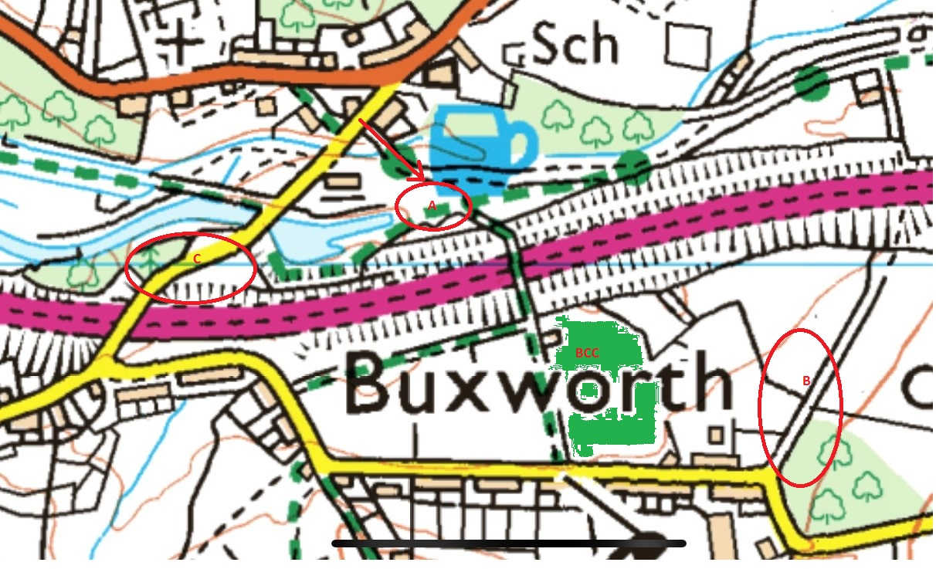

  - The main pavilion will remain CLOSED to all except club officials/keyholders. This will include all changing rooms.
  - Players must therefore arrive dressed in whites and ready to begin play. Where this is possible, all personal cricket equipment should remain in the participant’s car. Where no car is available a sheltered outdoor space will be available to store equipment bags.
  - Drinks or teas will not be available at the club while the current level of restrictions are in place. All participants must therefore bring their own food and drink. Drink bottles must not be shared.
  - Toilets will remain open during matches. The club will arrange for regular cleaning of touchpoints.
  - Only one scorer must be in the scorebox at any one time. No players are allowed in the scorebox. If scoring must be performed outside the scorebox a portable scoreboard is available. Use of communal scorebooks should be avoided.

- Wet weather arrangements

  - In the event of delays due to wet weather, all participants should return to their own car if possible. It is important that only members of the same household should shelter in the same car.
  - Where it is not possible to return to a car, gazebos will be provided (at senior games only) to offer shelter from the elements. Depending on circumstances, this space may be at a premium - social distancing must still be maintained. It is therefore recommended that participants in senior games bring a suitable umbrella if a car is not available.
  - It will not be possible to shelter in the main pavilion.

- Documentation

  - A register will be kept of all participants (players, scorers and officials) and their contact details for 21 days. This is to enable contact tracing in the event of any participant subsequently being found to be COVID positive. The register will be destroyed at the end of the 21 day retention period.
  - In order to aid in the completion of the register in a timely manner, it would be appreciated if the visiting captain could provide details of his team and scorers to the club in advance.

